**REPORT ON STUDENTS’ INDUSTRIAL WORK EXPERIENCE SCHEME**

**AT**

**AMBIANCE BIM SOLUCTIONS**

**BY**

**ADANU EDOR GODWIN**

**(BHU/21/09/01/0039)**

**Submitted to**

**DEPARTMENT OF ARCHITECTURE,**

**FACULTY OF ARCHITECTURE**

**BINGHAM UNIVERSITY KARU,**

**NASARAWA STATE, NIGERIA**

**SUBMITTED IN PARTIAL FULFILMENT OF THE**

**REQUIREMENTS FOR THE AWARD OF BACHELOR**

**OF SCIENCES (HONS) DEGREE IN ARCHITECTURE**

**OCTOBER 2024**

# CERTIFICATION

This is to certify that this technical report was prepared by ADANU EDOR GODWIN (BHU/21/09/01/0039).Following a six month SIWES training under the supervision of Dr. Odaudu Ugbede Sunday In the Department of Chemical Sciences, Faculty of Sciences and Technology, Bingham University.

**____________________________ ____________________________________**

MR Odaudu ugbede **(Supervisor) DATE**

**____________________________ ____________________________________**

Mrs Ruth martin (**Head of Department) DATE**

**____________________________ ____________________________________**

Arc Emmamoge (**University SIWES Coordinator) DATE**

# ACKNOWLEDGEMENT

I would like to express my heartfelt gratitude to everyone who contributed to the successful completion of this IT report. First and foremost, I thank my architectural firm, ITF Office, for their invaluable support and insights throughout this project. Your expertise and guidance were instrumental in shaping my understanding and approach. I would also like to extend my appreciation to my school for providing the resources and environment conducive to my learning and growth. The encouragement from my professors and supervisors

Table of Contents

CERTIFICATION i

ACKNOWLEDGEMENT ii

CHAPTER ONE 1

INTRODUCTION 1

1.1 INTRODUCTION TO SIWES 1

AIMS AND OBJECTIVES 2

1.2 HISTORY OF SIWES 3

1.3 LOCATION OF ORGANIZATION 3

1.4 MANDATE OF ORGANIZATION 3

CHAPTER 2 4

2.1 LOCATION OF ORGANIZATION 4

2.2 HISTORY OF ORGANIZATION 4

2.3 MANDATE OF THE ORGANIZATION 4

2.4 ORGANIZATIONAL STRUCTURE 4

CHAPTER 3 6

ACTIVITIES THAT TOOK PLACE DURING THE IT 6

3.1 INTRODUCTION 6

3.2 SITE WORK 6

3.3 OFFICE WORK 15

CHAPTER 4 25

CONCLUSION AND RECOMMENDATION 25

CONCLUSION 25

RECOMMENDATIONS 25

REFERENCES 26

# CHAPTER ONE

# INTRODUCTION

## 1.1 INTRODUCTION TO SIWES

The Students Industrial Work Experience Scheme (SIWES) is a program aimed at exposing students offering various courses to a professional and practical environment in order to gain practical knowledge about their various fields of study. It is designed to solve the problem of lack of adequate practical skills preparatory for employment in industries by Nigerian graduates of tertiary institutions (plasu.edu.ng, 8/10/2023). It is a skills training programme designed to expose and prepare students of universities and other tertiary institutions for the Industrial Work situation they are likely to meet after graduation. It is also a planned and structured programme based on stated and specific career objectives which are geared towards developing the occupational competencies of participants (Mafe, 2009).

Consequently, the SIWES programme is a compulsory graduation requirement for all Nigerian university students offering certain courses (noun.edu.ng, 8/10/2023). The scheme is aimed at bridging the existing gap between theory and practice of Sciences, Agriculture, Medical Sciences (including Nursing), Engineering and Technology, Management, and Information and Communication Technology and other professional educational programmes in the Nigerian tertiary institutions. It is aimed at exposing students to machines and equipment, professional work methods and ways of safeguarding the work areas and workers in industries, offices, laboratories, hospitals and other organizations (noun.edu.ng, 8/10/2023).

## AIMS AND OBJECTIVES

1. Provide Practical Training: To expose students to real-world industrial environments where they can apply the theoretical knowledge gained in their academic institutions
2. Bridge the Gap: To bridge the gap between theoretical education and practical work skills, helping students to understand how their academic learning translates into practice in the workplace.
3. Improve Employability: To enhance students' employability by equipping them with skills and experience that are directly relevant to the demands of the labor market.
4. Promote Self-reliance: To encourage self-reliance among students by helping them develop problem-solving, teamwork, and professional skills that are essential in the workplace.
5. Gain Industry-Specific Experience:SIWES enables students to acquire specialized knowledge and experience that is directly related to their future career paths.
6. Promote Self-Confidence:Working in a real industrial environment boosts students' self-confidence and enhances their ability to work independently and as part of a team
7. Strengthen the Curriculum: Feedback from industries where students undergo their SIWES can be used to update and improve the academic curriculum, ensuring it aligns with industry needs. In essence, SIWES plays a crucial role in preparing students for the challenges of the job market by offering practical training, industry exposure, and fostering the development of essential professional skills.

## 1.2 HISTORY OF SIWES

The **Students Industrial Work Experience Scheme (SIWES)** was established by the Federal Government of Nigeria in 1973 as a response to the growing need for students to acquire practical, hands-on experience in industries related to their fields of study. The scheme was designed to bridge the gap between theoretical knowledge gained in academic institutions and the practical skills required in the workplace.

## 1.3 LOCATION OF ORGANIZATION

Ambiance BIM Solution is located at suite 211 elyon plaza, 1st avenue, opposite dalchi fitness center, gwarinpa, Abuja

## 1.4 MANDATE OF ORGANIZATION

Ambiance BIM Solution is a registered architectural firm that deals majorly on consultation, engineering, and architectural services. Ambiance is aimed at improving the welfare of Nigerians through the provision of high quality architectural design, luxurious housing (ambianceBIMsolutions@gmail.com), 15/10/2024

# CHAPTER 2

## 2.1 LOCATION OF ORGANIZATION

Ambiance BIM Solution is located at suite 211 elyon plaza, 1st avenue, opposite dalchi fitness centre, gwarinpa, Abuja.

## 2.2 HISTORY OF ORGANIZATION

Ambiance BIM Solution started in 2009, this was after Mr. Kelechi Ukaegbu decided to start his very own firm after working as a draft man for several firms. He then worked hard to start ambiance BIM solution in 2009 and has continued to provide the public with the best luxury design eye will ever see and was appointed the chief architect in the construction and building of the governor lodge in

asokoro. Today, ambiance has design all over nigeria with its head office in Abuja

## 2.3 MANDATE OF THE ORGANIZATION

Ambiance BIM Solution is a registered architectural firm that deals majorly on consultation, engineering, and architectural services. Ambiance is aimed at improving the welfare of Nigerians through the provision of high quality architectural design, luxurious housing (ambianceBIMsolutions@gmail.com, 15/10/2024

## 2.4 ORGANIZATIONAL STRUCTURE

Ambiance BIM Solution is headed by Mr. Kelechi Ukaegbu who is the Director (D), it then has a managing director which is eng Joseph c. omerua. ambiance has three main departments which are the Technical, administrative, legal department as can be seen in fig 2.1. The technical department comprises of the company’s construction team (architects, engineers, and site supervising staff). The admin department comprises of the head administrative officer. The legal department is made up of the company’s lawyers who handle all the legal matters in the company.

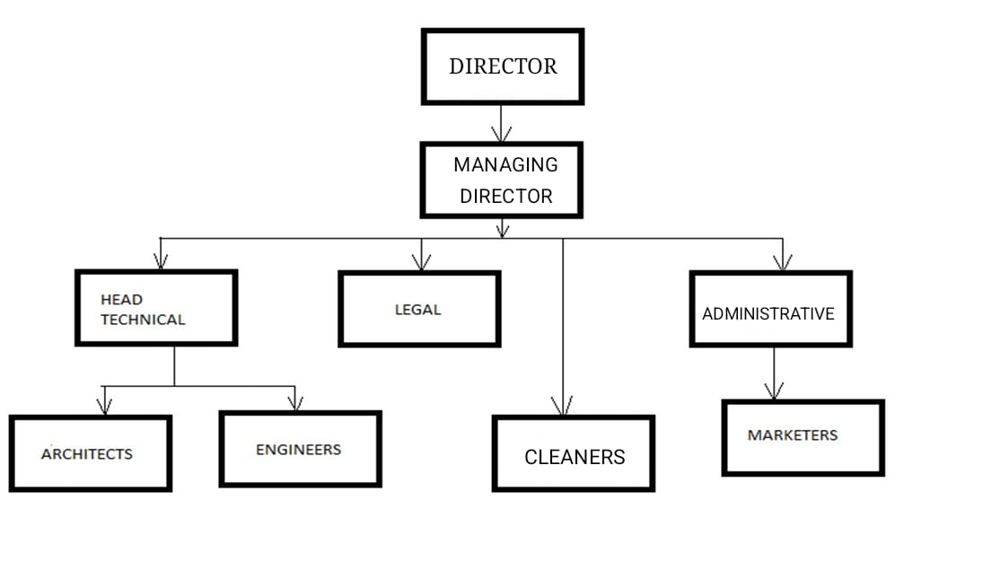

Fig. 2.1(Ambiance BIM Solution organizational chart)

# CHAPTER 3

# ACTIVITIES THAT TOOK PLACE DURING THE IT

## 3.1 INTRODUCTION

I completed a six-month SIWES attachment at Ambiance BIM Solutions, where I gained valuable experience in both site and office environments. On-site, I was actively involved in observing and supervising various stages of construction, which included tasks such as setting out, trench digging, foundation work, and overseeing general building activities. In the office, my responsibilities were centered around drafting, designing, and creating 3D models. I also assisted with running errands and worked collaboratively with other professionals in the office to support ongoing projects.

## 3.2 SITE WORK

My on-site experience began with observation, where I had the opportunity to tour the Ambiance project at Life Camp, Abuja. I was able to witness several stages of structural work,which includes

1. Setting out,
2. block laying
3. Stair case casting
4. Lintel casting
5. Slab casting
6. roofing
7. wall plastering
8. Remodeling an existing building
9. **Setting out**: is the process of transferring construction design details from drawings to the actual site, ensuring that the building is positioned and aligned correctly. It involves marking the locations, levels, and dimensions for various structural elements. There are different methods of taking a set out what we used was the peg and line methods which involved Using pegs, *string line, and sand dust . Pegs are placed at key points to mark the layout. A string line is stretched between the pegs to create straight reference lines. Sand dust is applied along the string to visibly mark the layout on the ground. This method provides a clear, cost-effective way to ensure accurate alignment for foundations and walls, ideal for smaller projects.

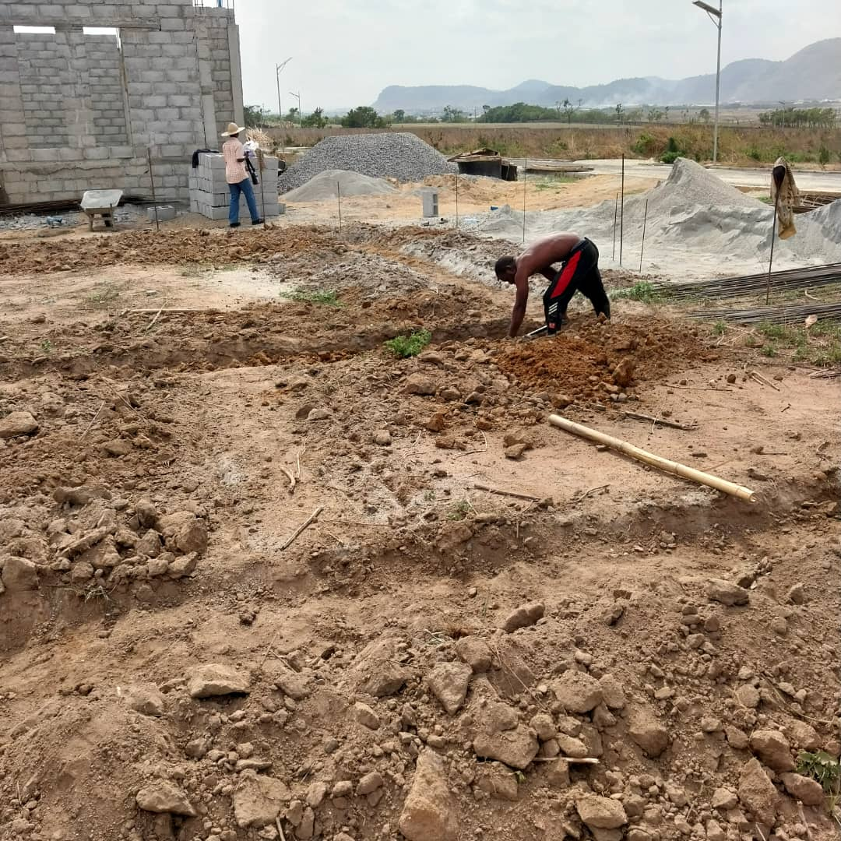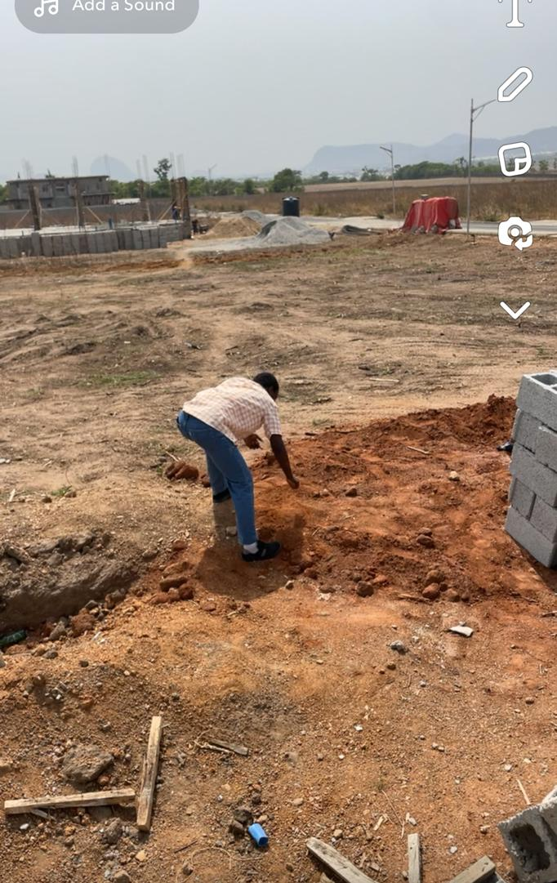

1. **Block laying**: is the process of constructing walls and other structures by stacking masonry blocks*(such as concrete, clay, or cement blocks) and securing them with mortar. The blocks are arranged in horizontal layers, with mortar applied between them to hold them in place and provide stability. Block laying is commonly used in residential, commercial, and industrial construction for building walls, foundations, and partitions due to its strength, durability, and fire resistance. Proper alignment and leveling of blocks are crucial for ensuring the structural integrity of the finished wall.

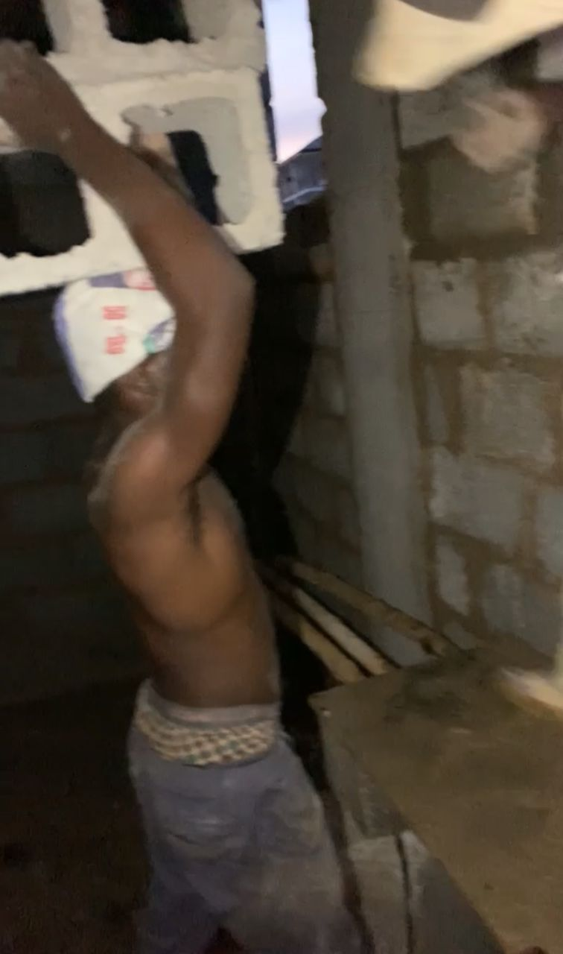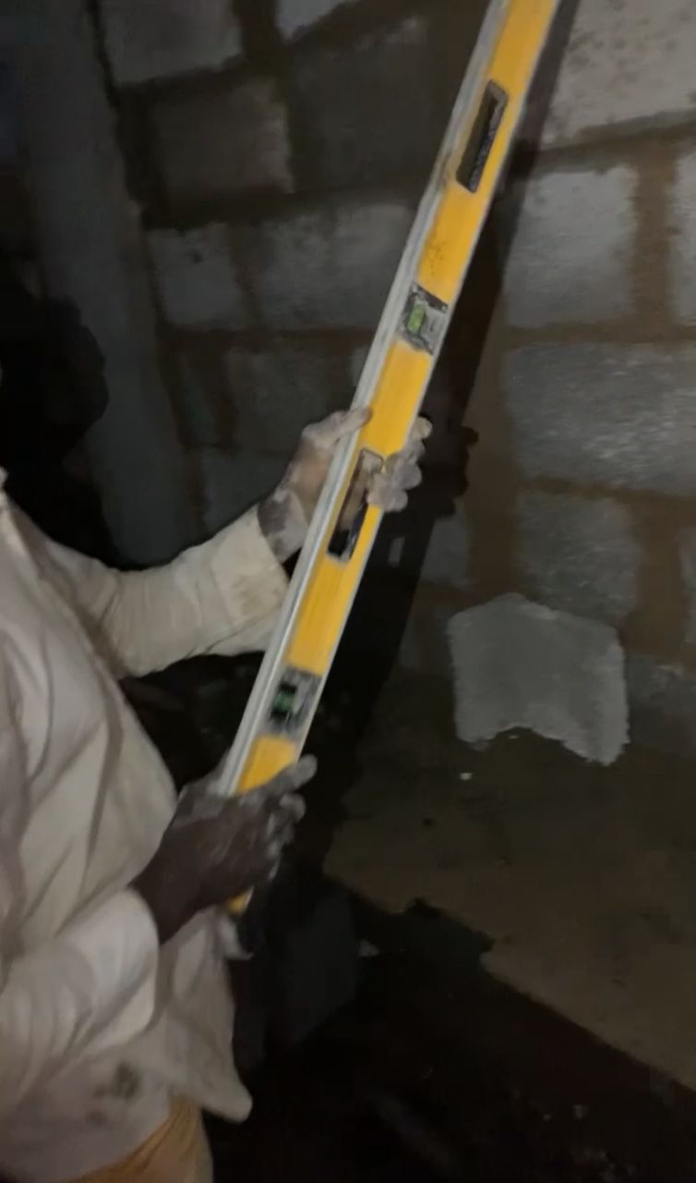

1. **Staircase casting:** The staircase casting process involves creating staircases using concrete, typically through a series of steps. Here's a brief overview:
2. Preparation The site is prepped, formwork is built, and reinforcement (rebar) is placed.
3. Formwork & Molding: Molds are set for the stairs, and rebar is positioned for strength
4. Pouring Concrete: Concrete is mixed and poured into the molds, filling each step4
5. Vibration & Compaction: The concrete is vibrated to remove air pockets and ensure uniformity.
6. Curing: The concrete is kept moist for several days to harden properly.
7. Demolding & Finishing: The molds are removed, and the surface is smoothed or finished as needed.
8. Inspection & Use:The staircase is inspected, and once approved, it's ready for use. This process can be done on-site (in-situ) or with pre-cast stairs that are made in a factory and installed later.

|  |  |
| --- | --- |
|  |  |

|  |  |
| --- | --- |
|  |  |

1. **Lintel casting**: is the process of creating a lintel, which is a horizontal structural beam placed above windows or doors to support the weight of the wall above. Here's a brief explanation of the steps:
2. Design & Planning: The size, load-bearing capacity, and material of the lintel are determined based on the opening's dimensions and the wall load.
3. Preparation: A formwork or mold is set up to shape the lintel, and reinforcement (rebar) is arranged for strength.
4. Concrete Pouring: Concrete is mixed and poured into the formwork, fully covering the rebar.
5. Vibration & Compaction: The concrete is vibrated to remove air pockets and ensure uniform consistency.
6. Curing: The lintel is left to cure, allowing the concrete to harden and reach its full strength.
7. Demolding: After curing, the formwork is removed, and the lintel is ready for installation. Lintel casting ensures a strong, durable support for openings in walls.

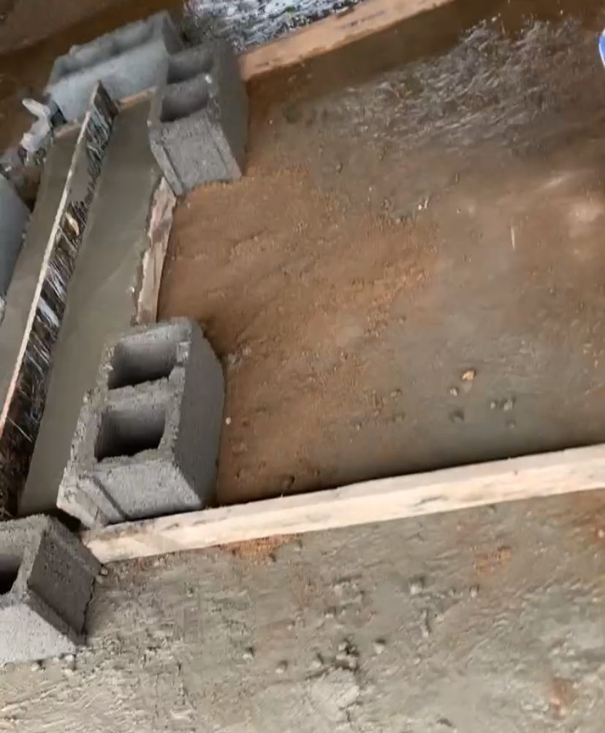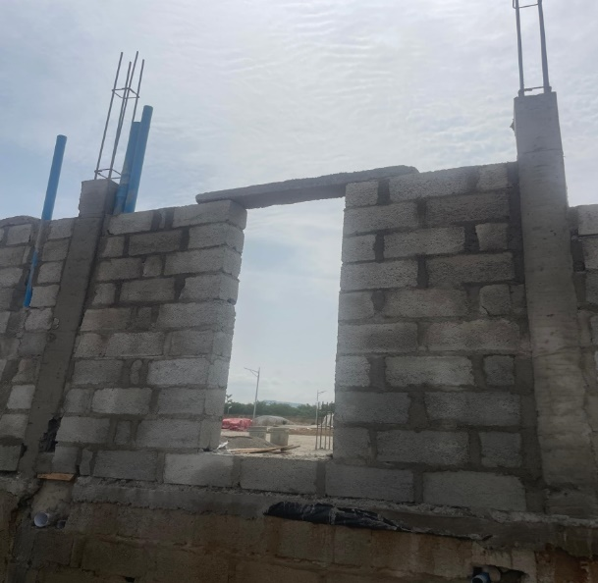

1. **Slab casting**: Casting a floor slab involves pouring concrete to create a solid floor surface. Here’s a brief overview of the steps:
   1. Design & Planning: Determine dimensions, thickness, and reinforcement needs.
   2. Preparation: Set up formwork, level the ground, and clean the site.
   3. Reinforcement: Place steel rebar or mesh inside the formwork for strength.
   4. Concrete Pouring: Mix and pour concrete into the formwork, covering the reinforcement.
   5. Vibration & Compaction: Vibrate the concrete to remove air pockets and level the surface.
   6. Curing: Keep the slab moist for several days to allow proper hardening.
   7. Demolding & Finishing: Remove the formwork and smooth the surface if needed.
   8. Inspection & Use: Inspect for cracks and ensure the slab is structurally sound. This process is key for creating durable, flat floors in buildings.

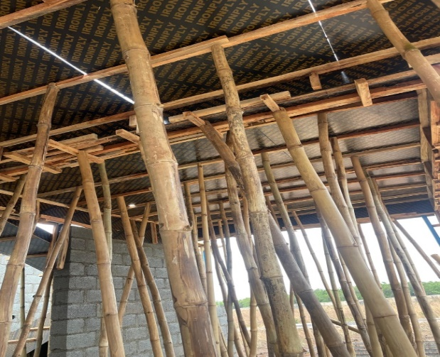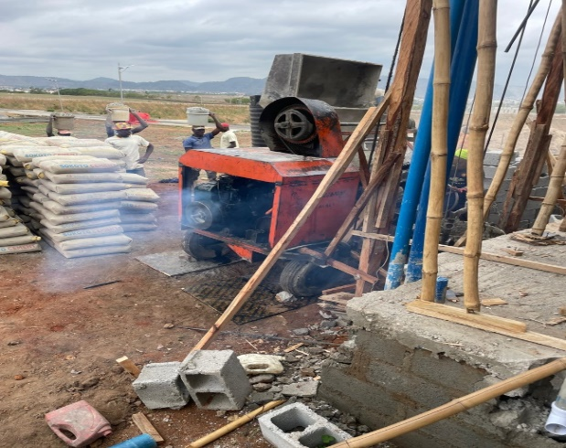

|  |  |
| --- | --- |
|  |  |

1. **Roofing:** refers to the process of constructing or installing a roof structure on a building to provide protection from the elements. It involves various materials and techniques polystyrene was one of the materials used in this process because of its Thermal Insulation** Polystyrene, especially Expanded Polystyrene (EPS) and Extruded Polystyrene (XPS), provides excellent thermal insulation. This helps to regulate the temperature inside buildings by reducing heat transfer. In cold climates, it helps retain heat within the building, while in warmer climates, it prevents excessive heat from entering. As a result, buildings can maintain more consistent indoor temperatures, improving energy efficiency and comfort. 2. Lightweight Polystyrene is incredibly light, making it easy to handle and install. This reduces the overall weight load on the building structure, which is particularly beneficial for certain types of roofs, such as flat roofs or structures with limited load-bearing capacity.

|  |  |
| --- | --- |
|  |  |

1. **Wall plastering:** wall plastering is the process of applying a smooth plaster layer to walls for a clean finish enhance durability, and improve aesthetics.

Here's how it's done:

1. 1.Prepare the Surface: Clean and repair the wall.
2. Mix Plaster: Combine cement, sand, and water (or gypsum for dry plaster).
3. 3.Apply Base Coat: Spread the first, thicker layer of plaster evenly.
4. Smooth & Level: Use a trowel to smooth and level the surface.
5. Curing: Let the base coat set and dampen to prevent cracking.
6. Apply Finish Coat: Add a thinner, smooth final layer.
7. Final Smoothing: Polish the finish for a smooth surface. After curing, the wall is ready for painting or further finishes.

|  |  |
| --- | --- |
|  |  |

1. **Remodeling:** Remodeling an existing building** refers to the process of altering or updating a structure to improve its function, design, or appearance. This may involve changes to the layout, structure, systems (like plumbing or electrical), or aesthetic features (such as flooring or finishes) to better meet current needs or modern standards.

|  |  |
| --- | --- |
|  |  |

## 3.3 OFFICE WORK

While in the office, I was involved in a wide range of tasks, including running errands, drafting, and working on building designs and remodels. I also focused on 3D modeling. A key aspect of my experience was analyzing official working drawings and designs, which significantly enhanced my understanding of the construction process. Additionally, I had the opportunity to collaborate with other professionals in the built environment, engaging in discussions about modern design and construction practices

1. 1.Drafting of floor plans
2. 2.Modelling
3. 3.working drawings
4. 4.Rendering with lumion
5. 5.Experience to Nigerian building and road research institute(NBRRI)
6. Drafting of floor plans: Drafting floor plans with ArchiCAD involves creating a digital building layout using tools to draw walls, add doors/windows, and define spacesArchiCAD simplifies the design process with its BIM tools, ensuring accuracy and collaboration.

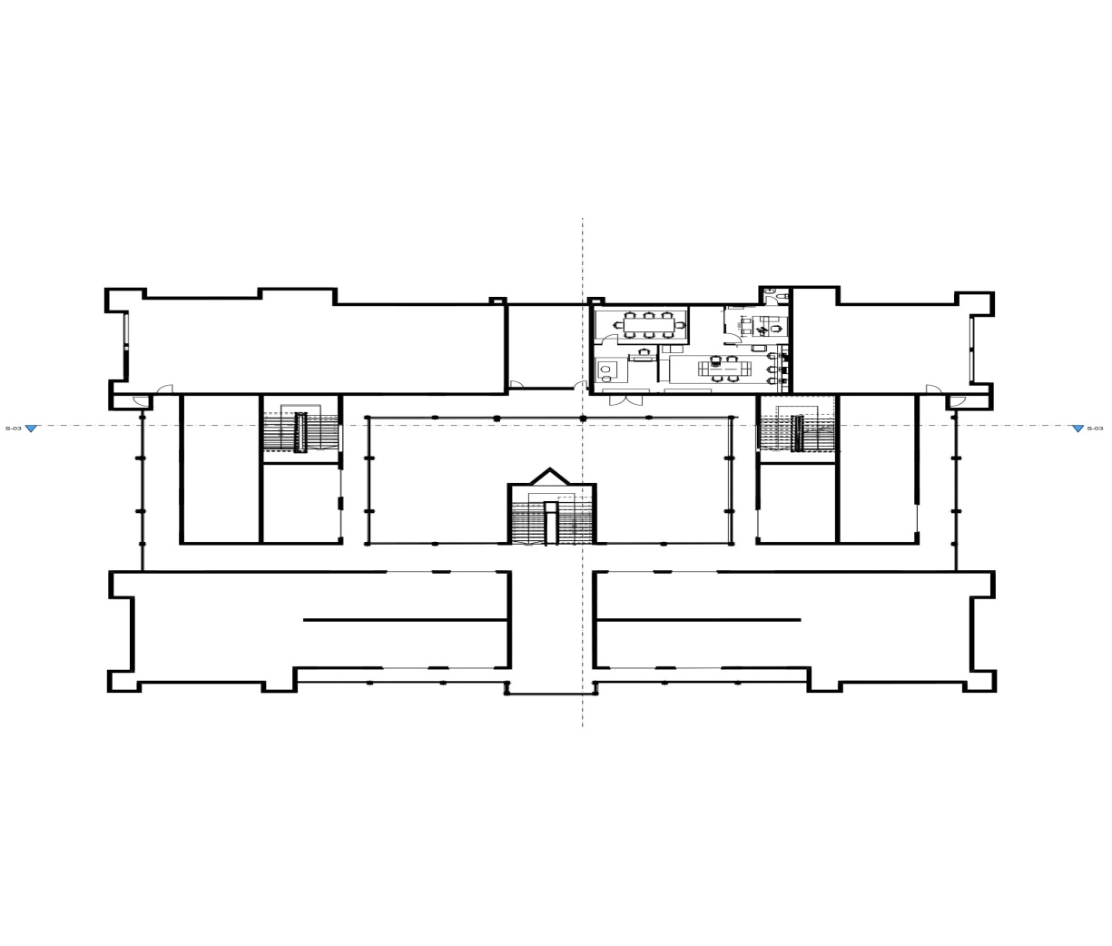

*Ground Floor Plan 0f Elyon Plaza Gwarinpa*

1. Modeling: Modeling in architecture refers to creating a 3D digital representation of a building or structure using specialized software. It involves designing and visualizing the physical components (walls, floors, roofs, etc.) in three dimensions to understand the form, structure, and spatial relationships. Key Points: - 3D Representation: Creating a virtual model of the building or space. - Design Elements: Includes walls, doors, windows, roofs, and structural components. -**Visualization: Helps in understanding the design, detecting issues, and presenting ideas. - *Software: Common tools include ArchiCAD, Revit, SketchUp, and Rhino. Modeling helps architects and designers visualize, test, and refine designs before actual construction.

|  |
| --- |
| Model of a toilet |
|  |

Model of a kitchen

|  |
| --- |
| *Model of Elyon Plaza Located in Gwarinpa* |

1. Working drawings: Working drawings are detailed, technical drawings used in construction to communicate the design, dimensions, materials, and assembly instructions for a building or structure. They are essential for contractors, builders, and engineers to accurately construct the project. They are used to interpret the following.

**Detailed Information:** Working drawings include floor plans, elevations, sections, and construction details.

**Dimensions & Specifications:** They provide exact measurements, material types, and construction methods to ensure the design is built accurately.

**Construction Guidance:** These drawings are used by the construction team to execute the design according to the plans.

**Compliance:** They ensure that the project complies with building codes, safety regulations, and industry standards. Working drawings act as a roadmap, guiding the entire construction process from start to finish.

|  |  |
| --- | --- |
|  |  |
|  |  |
|  |  |

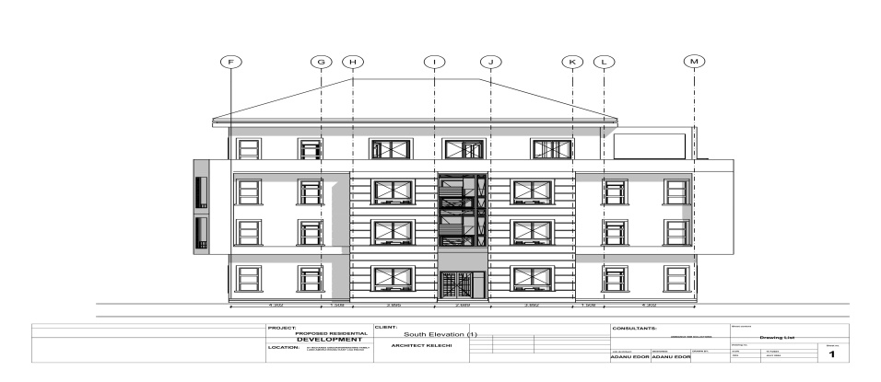 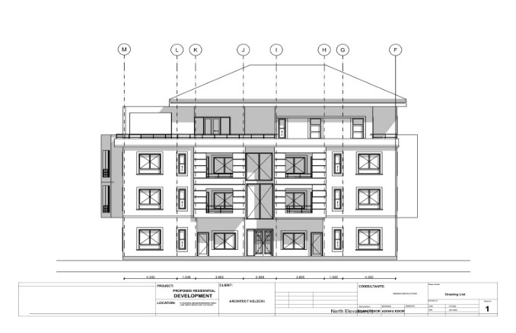

1. Rendering: Rendering with Lumion is the process of creating realistic visual representations of architectural designs using Lumion software. It involves importing a 3D model from programs like SketchUp, Revit, or ArchiCAD, then enhancing the model by applying materials, textures, and adjusting lighting. The software allows users to simulate real-world conditions, adding elements like trees, water, and environmental effects to the scene. Once the scene is set up, Lumion’s rendering engine generates high-quality images or animations, showcasing how the project will look in real life. This process helps architects and designers present their ideas in a visually compelling way to clients and stakeholders.

|  |
| --- |
|  |
|  |

|  |
| --- |
|  |
|  |

1. Experience to Nigerian building and road research institute(NBRRI)

During my visit to the Nigerian Building and Road Research Institute (NBRRI), I had the opportunity to engage in a variety of technical tasks and gain practical exposure to some of the institute's operations. This report provides an overview of my activities during my time at NBRRI.

Day 1: Introduction to Sketchup Modelling On the first day of my visit, I was introduced to the primary task I would be handling during my time at the institute. This task involved the use of Sketchup to model shading devices for building models. The shading devices were to be designed with varying sizes, angles, and styles to explore their impact on the building design.

After being introduced to the project, I immediately began working on creating these shading device models. My proficiency in Sketchup allowed me to efficiently construct the designs, considering different parameters for each model. This task was critical in understanding the adaptability of shading devices based on the architectural requirements of different structures.

Teaching Others Sketchup Once I became comfortable with my project, I extended my knowledge by assisting others at the institute. I conducted a session where I taught the team how to operate Sketchup and how to recreate the different models. The training was successful, and by the end, the team was able to work independently on their own models. Final Days: Laboratory Testing Towards the end of my visit,

I had the chance to visit NBRRI's laboratory, where I observed and participated in some of the essential tests conducted on construction materials. Specifically, I was involved in testing the strength of cement and concrete blocks, and my last day we did a test to know the quality of the granite before its being purchase

* Cement Strength Test: The cement was subjected to a strength test to ensure it met the required standards for construction use.
* Concrete Block Strength Test: Similar tests were conducted on concrete blocks to determine their load-bearing capacity and overall strength. These tests provided me with valuable insight into the practical applications of the theories learned in architecture and engineering, as well as the importance of material testing in the construction industry.

A soil test is a scientific analysis of the physical and chemical properties of soil, typically conducted before construction projects. The purpose of the test is to assess the soil’s suitability for supporting structures and to guide the design of foundations,

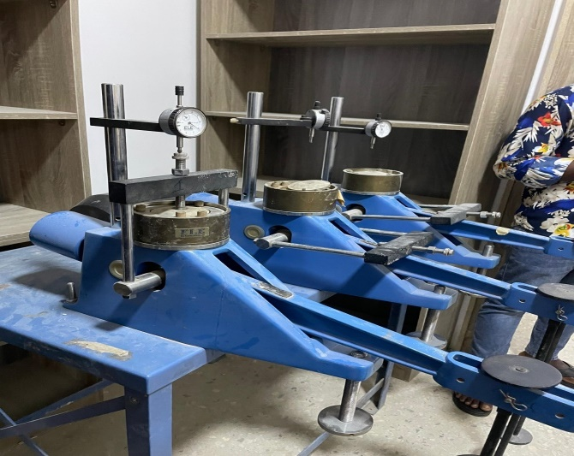 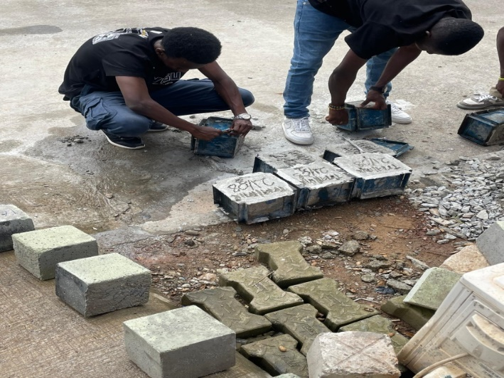

Soil testing machine Concrete block strength test

# CHAPTER 4

# CONCLUSION AND RECOMMENDATION

## CONCLUSION

The SIWES program was instrumental in helping me develop new skills and enhance the ones I already possessed. It strengthened my communication abilities with professionals in the built environment and deepened my understanding of the ever-evolving nature of architectural practice. Overall, the program successfully met its objectives by providing practical experience and valuable insights into the field of architecture.

## RECOMMENDATIONS

* Schools should provide official recommendations for organizations where students can complete their SIWES attachment. However, students should still have the freedom to choose their preferred place of attachment.
* All departments currently not participating in the SIWES program should be included in the scheme, as the practical experiences gained through SIWES would positively impact graduates across various fields of study.

# REFERENCES